**Dashboard UI**

Dashboard should have a menu feature to pick what to work eg:

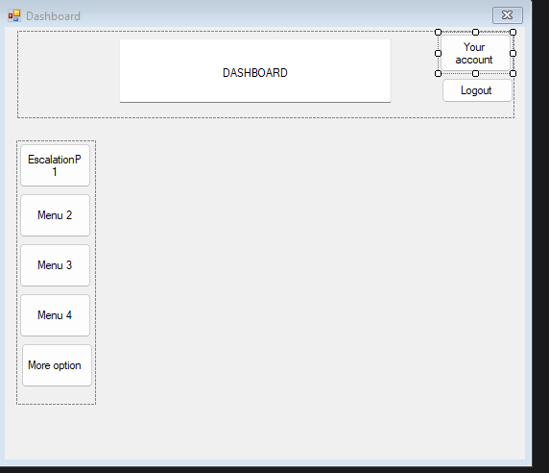

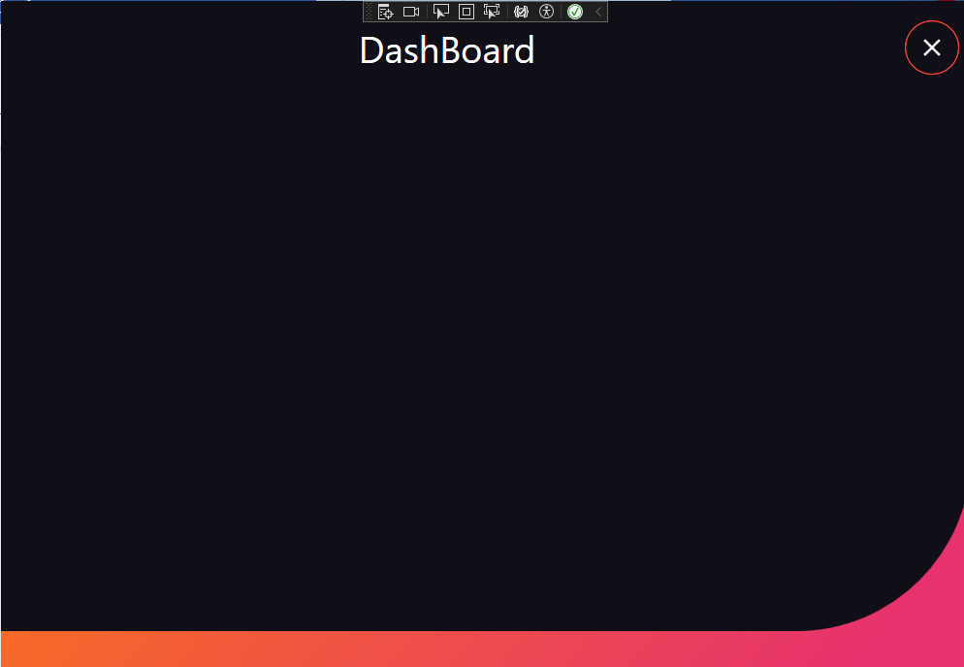

**Image: When clicked to this menu it leads to the escalation form ;**

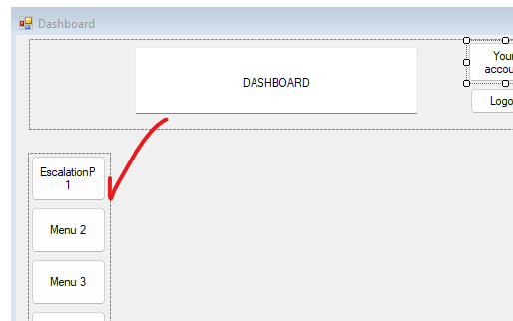

**Escalation form :**

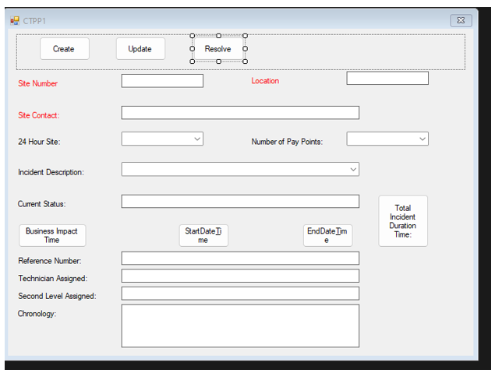

**Final result should be like a word doc format :**

|  |
| --- |
| **Site Number / Location:** |
|  |
| **Site Contact:** |
| **24 Hour Site:**                                            **Number of Pay Points:** |
| **Incident Description:** |
| **Current Status:** |
| **Business Impact:** |
| **Business Impact Time:** |
| **Start Time:**  **End Time:** |
| **Total Incident Duration Time:** |
| **Reference Number:** |
| **Technician Assigned:** |
| **Second Level Assigned:** |
| **Chronology:** |